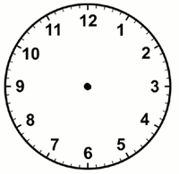

Analogue

Digital

Analogue

Digital

Analogue

Digital

Analogue

Digital

Analogue

Digital

Analogue

Digital

Analogue

Digital

Analogue

Digital