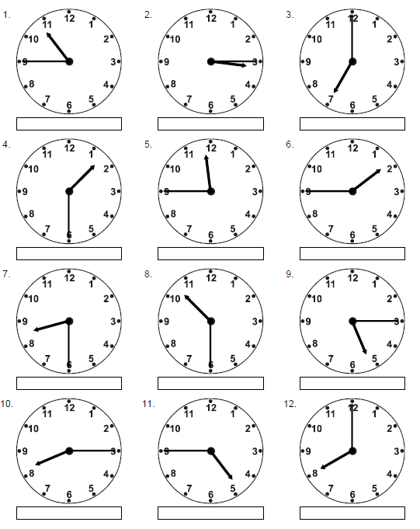
I can read quarter past and quarter to times

